**Technical Test Answers**

Nama : Jafar Shodiq

File : ipynb (terlampir)

**Dataset**

1. Mengkategorikan semua jkt-hub menjadi Jakarta

for i in df['kota']:

if 'hub' in i:

df['kota'] = df['kota'].str.replace(i, 'jakarta')

if 'jakarta' in i:

x = i[:7]

df['kota'] = df['kota'].str.replace(i, x)

df[['kota', 'status']][df['kota'].str.contains('jakarta')].sample(10)

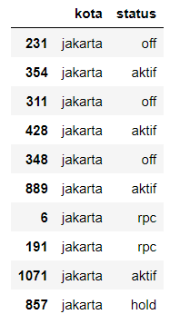

1. Jumlah ATM yang aktif di top 5 kota

df2 = df[['kota', 'status']]

df2['kota'][df2['status'].str.contains('aktif')].value_counts().head()

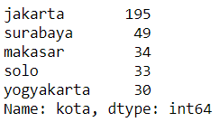

df2['kota'][df2['status'].str.contains('aktif')].value_counts().head().sort_values().plot(kind='barh', figsize=(10, 5))

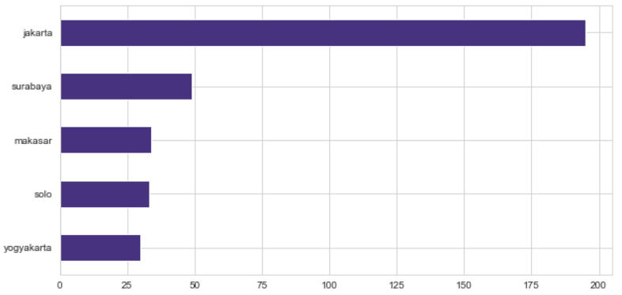

1. Di kota Jakarta, penyewaan ATM yang aktif ada di kategori lokasi mana saja

df3 = df[['lokasi']][(df['kota']=='jakarta') & (df['status']=='aktif')]

Me-list semua kategori yang mungkin:

* Swalayan

lst_swalayan = []

lst_swalayan_cat = ['toko', 'swalayan', 'tip top', 'carefour', 'indomaret', 'alfa mart', 'alfamart', 'giant', 'super indo']

for i in lst_swalayan_cat:

for x in list(df3['lokasi'][df3['lokasi'].str.contains(i)]):

lst_swalayan.append(x)

len_swalayan = len(list(set(lst_swalayan)))

* SPBU

lst_spbu = []

lst_spbu_cat = ['spbu']

for i in lst_spbu_cat:

for x in list(df3['lokasi'][df3['lokasi'].str.contains(i)]):

lst_spbu.append(x)

len_spbu = len(list(set(lst_spbu)))

* Kantor Cabang Pembantu (KCP)

lst_kcp = []

lst_kcp_cat = ['kcp']

for i in lst_kcp_cat:

for x in list(df3['lokasi'][df3['lokasi'].str.contains(i)]):

lst_kcp.append(x)

len_kcp = len(list(set(lst_kcp)))

* Mall

lst_mall = []

lst_mall_cat = ['mall', 'plaza']

for i in lst_mall_cat:

for x in list(df3['lokasi'][df3['lokasi'].str.contains(i)]):

lst_mall.append(x)

len_mall = len(list(set(lst_mall)))

* Universitas

lst_univ = []

lst_univ_cat = ['universitas', 'univ', 'kampus']

for i in lst_univ_cat:

for x in list(df3['lokasi'][df3['lokasi'].str.contains(i)]):

lst_univ.append(x)

len_univ = len(list(set(lst_univ)))

* PLN

lst_pln = []

lst_pln_cat = ['pln']

for i in lst_pln_cat:

for x in list(df3['lokasi'][df3['lokasi'].str.contains(i)]):

lst_pln.append(x)

len_pln = len(list(set(lst_pln)))

Visualisasi:

new_df_lokasi = pd.DataFrame(columns=('Cat', 'Count'))

cat_lst = ['Swalayan', 'Mall', 'SPBU', 'Universitas', 'KCP', 'PLN']

len_lst = [len_swalayan, len_mall, len_spbu, len_univ, len_kcp, len_pln]

new_df_lokasi['Cat'] = cat_lst

new_df_lokasi['Count'] = len_lst

new_df_lokasi.sort_values('Count', ascending=False, inplace=True)

new_df_lokasi

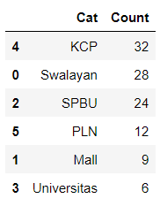

plt.figure(figsize=(10, 5))

sns.barplot(x='Cat', y='Count', data=new_df_lokasi)

plt.title('Kategori Lokasi Sewa ATM di Jakarta yang Aktif')

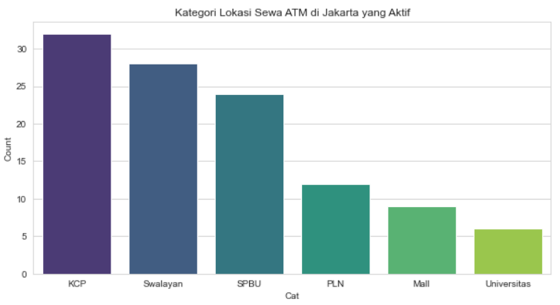

1. Korelasi sheet SEWAATM dan Data Aktifitas

data2 = pd.read_excel('../data-cleaned.xlsx', sheet_name='data_aktifitas', index_col=0)

df4 = data2['lokasi']

df5 = df[['lokasi']][df['status']=='aktif']

lst_swalayan_da = []

lst_swalayan_sa = []

lst_swalayan_cat = ['toko', 'swalayan', 'tip top', 'carefour', 'indomaret', 'alfa mart', 'alfamart', 'giant', 'super indo']

for i in lst_swalayan_cat:

for x in list(df4[df4.str.contains(i)]):

lst_swalayan_da.append(x)

for x in list(df5['lokasi'][df5['lokasi'].str.contains(i)]):

lst_swalayan_sa.append(x)

len_swalayan_da = len(list(set(lst_swalayan_da)))

len_swalayan_sa = len(list(set(lst_swalayan_sa)))

new_df = pd.DataFrame(columns=('cat', 'count'))

cat_lst = ['count_sewaatm', 'count_dataakifitas']

len_lst = [len_swalayan_sa, len_swalayan_da]

new_df['cat'] = cat_lst

new_df['count'] = len_lst

new_df

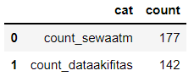

plt.figure(figsize=(10, 5))

sns.barplot(x='cat', y='count', data=new_df)

plt.title('Perbedaan Jumlah ATM Swalayan yang Aktif pada `SEWAATM` dan `Data Aktifitas`')

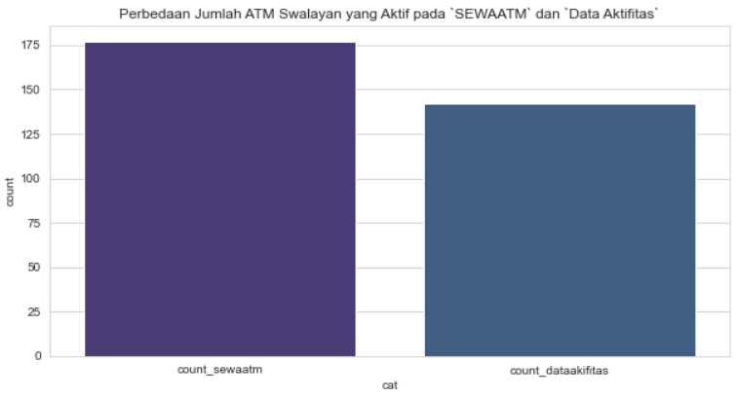

**SQL**

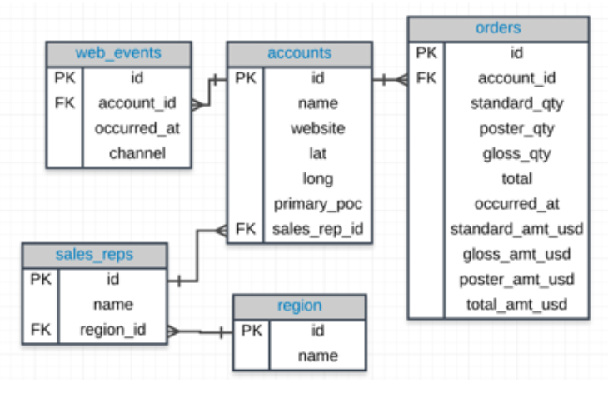

1. Provide the **name** for each region for every **order**, as well as the account **name** and the **unit price** they paid (total_amt_usd/total) for the order. However, you should only provide the results if the **standard order quantity** exceeds 100 and the **poster order quantity** exceeds 50. Your final table should have 3 columns: **region name**, **account name**, and **unit price**. Sort for the largest **unit price** first.

SELECT region.name AS region_name, accounts.name AS account_name, (orders.total_amt_usd/orders.total) AS unit_price

FROM accounts

JOIN orders

ON orders.account_id=accounts.id

JOIN sales_reps

ON sales_reps.id=accounts.sales_rep_id

JOIN region

ON region.id=sales_reps.region_id

WHERE orders.standard_qty>100 AND orders.poster_qty>50

ORDER BY unit_price DESC

1. Provide the **name** of the **sales_rep** in each **region** with the largest amount of **total_amt_usd** sales.

SELECT sales_reps.name, MAX(orders.total_amt_usd)

FROM sales_reps

JOIN accounts

ON sales_reps.id=accounts.sales_rep_id

JOIN orders

ON orders.account_id=accounts.id

WHERE sales_reps.region_id=1

UNION

SELECT sales_reps.name, MAX(orders.total_amt_usd)

FROM sales_reps

JOIN accounts

ON sales_reps.id=accounts.sales_rep_id

JOIN orders

ON orders.account_id=accounts.id

WHERE sales_reps.region_id=2

1. Find all the orders that occurred in 2015. Your final table should have 4 columns: **occurred_at**, **account name**, **order total**, and **order total_amt_usd**.

SELECT orders.occured_at, accounts.name, orders.total, orders.total_amt_usd

FROM orders

JOIN accounts

ON orders.account_id=accounts.id

WHERE orders.occured_at=2015